 | Sons of Union Veterans of the Civil War  Pennsylvania Department  Office of the Department Commander  403 Grand Circle, Scranton PA 18505-2870  wefjr.suvcw@gmail.com | 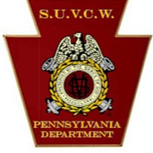

DEPARTMENT ORDER 17 16 February 2025
SERIES 2024-2025

SUVCW ASSISTANT EXECUTIVE DIRECTOR POSITION AVAILABLE

1. At the request of CinC Martin, I am pleased to announce that SUVCW is seeking a part-time Assistant Executive Director to support Executive Director Demmy in carrying out the work of the Order at National Headquarters.

2. Susan Mitchell, the former Asst Exec Dir, did an outstanding job but unfortunately had to step away last year for personal reasons.

3. The position is part-time 16 hours per week and must be performed in person at National HQ at the National Civil War Museum in Harrisburg PA. If you are not within commuting distance or moving to the area in the immediate future, please DO NOT apply.

4. The Asst Exec Dir position description is attached. Please read it carefully. This is a critical administrative position that requires dedication and attention to detail. DO NOT apply if you, on a whim, think it would be “fun” as it requires proficient computer suite and other administrative skills, and serious focus on the week-to-week grind of processing paperwork from across all our departments.

5. Nonetheless, this is an excellent opportunity to positively support our hard-working Executive Director and Brothers across our Order.

6. Although not explicitly stated, please email Exec Dir David Demmy execdir@suvcw.org to let him know of your initial interest in the Asst Exec Dir position; the sooner the better.

SO ORDERED IN FRATERNITY, CHARITY AND LOYALTY

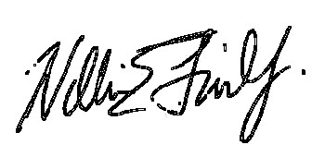 ATTEST:
William E. Fischer, Jr., PCC Rob Koenigsberg, PCC
Commander Secretary

