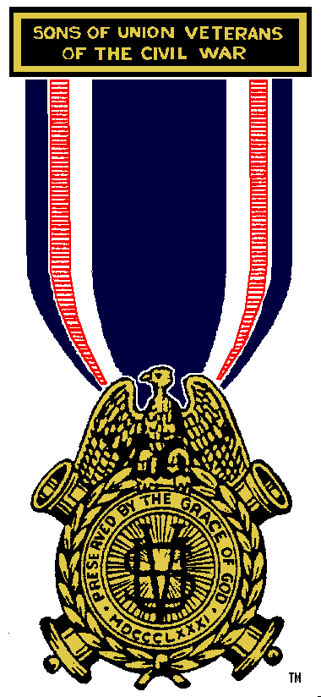 | Pennsylvania Department  Sons of Union Veterans of the Civil War  Office of the Patriotic Instructor  117 Pipers Pl  Chalfont, PA 18914  (215) 512-8961  drcf3@comcast.net  February 18, 2024  Department Patriotic Instruction #3  Series 2023-2024  Brothers, As we celebrate President’s Day in commemoration of the Birthdays of George Washington (Feb, 22, 1732 or Feb. 11, 1731 on the Julian Calendar) and Abraham Lincoln (Feb. 12, 1809) please remember the importance of these men in the creation and maintenance of our nation, and to educate the public on their service to the United States. Their memory must always be recognized and celebrated beyond one day a year.  In Fraternity, Charity, & Loyalty,  Theodore Zeman, PCC  Department of Pennsylvania Patriotic Instructor | 